**Driver Walk**

***Work-flow to Use Driver Walk***

The Driver Walk preference is accessed through **Load Template** and only one instance of it is permitted.

***Preference Overview***

A driver may move on foot for a vehicle changeover between very close locations after a break or a split break. Maximum walking distance and walking time are specified here.

Setting a high penalty reduces the number of walks.

***Templates Available from Optibus***

***Driver Walk***

**Purpose:**

As stated in the Overview **Prerequisites:** None. **Opening Dialog:**

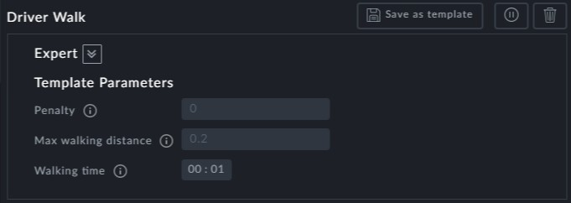

**Point to note:**

**Penalty**: The higher the penalty, the less the number of walks. You can leave the pen- alty at zero to prefer unlimited walks within the time and distance limits



**Max walking distance** and **Walking time**: Ensure that these two values are realistic and mutually consistent. The default shown of up to 200 m in 1 minute may be a bit demanding!

